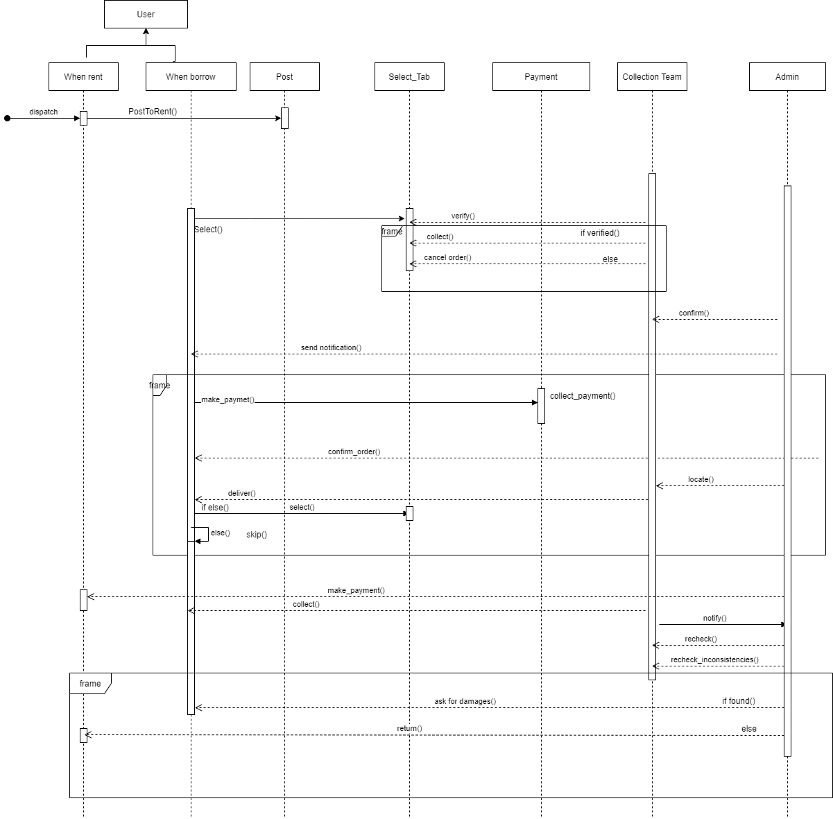 **Sequence Diagram for Rent-a-Gadget:**